AUCTION ITEMS:

- 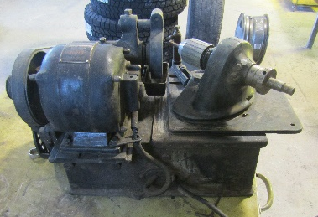

- 2008 Chevrolet Silverado 2500HD VIN 1GBHK29K18E207187
  - Kelly Blue Book Low: $3770.00
  - Odometer: 176,492 Miles

- 2008 Chevrolet Colorado VIN 1GCDT33E188229446
  - Kelly Blue Book Low: $2420.00
  - Odometer: 228,406 Miles

- 1984 Chevrolet C3500 VIN 1GBHC34M2EV140333
  - Kelly Blue Book Low: Not available on website, but there are similar vehicles listed for sale starting around $1600.00
  - Odometer: 184,412 Miles

- Craftsman 5HP Air Compressor
  - Ebay value: $250

- Miscellaneous Antique Grinder
  - Unknow Value

